
International Optimist Class Association (UK)

2025 Optimist Nationals – Regatta Fleet Safety Checklist

Item | Requirement | Class Rule
Painter | Not less than 5mm diameter.  Buoyant rope.  At least 8 metres long with loop tied 1m from bow.  securely fastened to the mast thwart or mast step | CR4.3 (b)
Mast Clamp | (or alternative mechanism) to prevent mast coming out of mast step if capsized | CR3.5.2.10
Buoyancy Bags | 3 x 45 litre (+/- 5 litre) bags serviceable and fixed properly  as per Annual Buoyancy Test | CR3.2.7.1
Bailers | 2 large bailers,  each minimum 1 litre capacity. Secured to boat | CR4.3 (a)
Paddle | “Praddle” type is recommended.  Paddle must be secured to hull with bungee or lanyard | CR4.3 (c)
Mainsheet | Detachable clip of recommended type which has a positive means of locking.  Recommended type  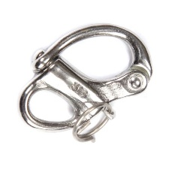 | IODA Safety warning
Mainsheet | Not permitted include:  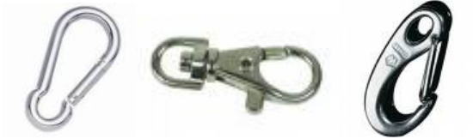 | IODA Safety warning
Boom span for mainsheet | Maximum gap of 100mm between boom and span rope  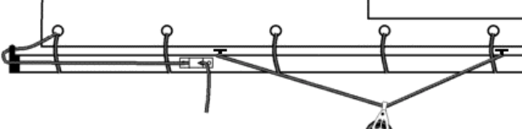  Max 100mm | CR3.5.3.8
Daggerboard | Secured to boat by bungee or lanyard | CR3.3.4
Rudder retaining clip | Retaining clip must be fitted and serviceable to prevent rudder becoming detached when capsized | CR3.4.5.2
Personal Flotation Device | Buoyancy Aid ISO 12402-5 (Level 50) or equivalent | CR4.2
Whistle | Securely attached to buoyancy aid | CR4.2

